The Association of Community Employment Programs for the Homeless

Volunteer Packet

Dear ACE Volunteer,

Thank you for choosing to volunteer with ACE! This registration packet is intended to help you better understand ACE’s mission, as well as volunteer roles and responsibilities. We want to ensure that you have the best volunteer experience possible, so please review the enclosed information closely.

If you have any questions or concerns, please do not hesitate to reach out to me by phone at 212-274-0550 X58, or by e-mail at ovanosch@acenewyork.org.

Thank you for choosing to volunteer with ACE!

Sincerely,

Olivia Van Osch
Project Manager
ACE

INTRODUCTORY STATEMENT

This Volunteer Orientation Packet is designed to acquaint you with ACE and provide you with information about the policies affecting your volunteer experience. You should read, understand, and comply with all provisions of the Volunteer Orientation Packet. It describes your responsibilities as a volunteer and outlines the programs developed by ACE. One of our objectives is to provide a work environment that is conducive to both personal and professional growth.

While every attempt has been made to create these personalized policies consistent with federal and state law, if an inconsistency arises, the policies will be enforced consistent with the applicable law.

No Volunteer Orientation Packet can anticipate every circumstance or question about policy. As ACE continues to grow, the need may arise and ACE reserves the right to revise, supplement, or rescind any policies or portion of the Volunteer Orientation Packet as it is deemed appropriate in its absolute discretion.

ABOUT ACE

ACE provides vocational rehabilitation services, job placement assistance, an employment retention program and housing opportunities for the formerly homeless men and women of New York City, enabling them to transition to self-sufficiency and establish economic independence. ACE's program structure is designed to address the barriers to employment, and provide the individualized support needed to break the cycle of incarceration, poverty and homelessness. We do this using a three-step approach:

Project Comeback:
Project Comeback is ACE's four to six month vocational rehabilitation program. The focus of the program is workforce development. Project Comeback provides job-readiness training, Adult Basic Education, supported work experience and job placement assistance. Participants graduate when they find full-time permanent employment.

Project Stay:
Project Stay is ACE's life-long aftercare program that assists graduates in retaining employment and supports them in the transition to self-sufficiency. It consists of regular group meetings, individual case management, financial incentives and the opportunity for educational advancement. Project Stay conducts monthly tracking of a graduate's employment status and wages for 21 months after he or she finds a job.

Project Home:
The mission of Project Home is to assist Project Comeback graduates in their transition to independent living by providing them with a 3 year rent subsidy to help them meet the financial demands of living in their own apartment. In return for the subsidy, participants will adhere to an established vocational plan geared towards increasing earning power.

ACE Non-Discrimination Policy

In order to provide equal opportunities to all individuals, decisions at ACE will be based on merit, qualifications, and abilities. ACE does not discriminate against any person because of race, color, creed, religion, sex, national origin, disability, age, genetic information or any other characteristic protected by law (referred to as "protected status"). This nondiscrimination policy extends to all terms, conditions and privileges of employment and volunteerism as well as the use of all company facilities, participation in all company-sponsored activities, and all employment actions such as promotions, compensation, benefits and termination of employment or volunteerism.

Any employees or volunteers with questions or concerns about any type of discrimination in the workplace are encouraged to bring these issues to the attention of their immediate supervisor. Employees and volunteers can raise concerns and make reports without fear of reprisal. Anyone found to be engaging in any type of unlawful discrimination will be subject to disciplinary action, up to and including termination of services.

VOLUNTEER CONFIDENTIALITY AGREEMENT

All information concerning clients, former clients, our staff, volunteers, and financial data, and business records of ACE is confidential. “Confidential” means that you are free to talk about ACE and about your position, but you are not permitted to disclose clients’ names or talk about them in ways that will make their identity known. No information may be released without appropriate authorization. This is a basic component of client care and business ethics. The board of directors, staff and our clients rely on paid and volunteer staff to conform to this rule of confidentiality.

ACE expects you to respect the privacy of clients and to maintain their personal and financial information as confidential. All records dealing with specific clients must be treated as confidential. General information, policy statements or statistical material that is not identified with any individual or family is not classified as confidential. Staff members are responsible for maintaining the confidentiality of information relating to other staff members and volunteers, in addition to clients.

Failure to maintain confidentiality may result in termination of your involvement with ACE. This policy is intended to protect you as well as ACE because in extreme cases, violations of this policy also may result in personal liability.

I have read ACE’s policy on confidentiality and the CONFIDENTIALITY AGREEMENT. I agree to abide by the requirements of the policy and inform my supervisor if I believe any violation (unintentional or otherwise) of the policy has occurred. I understand that violation of this policy will lead to disciplinary action up to and including termination of my service with ACE.

Signature: Date:

Social Networking and Blogging Policy

To protect ACE’ interests, volunteers must adhere to the following rules:

Volunteers may not post on a blog or social networking site during their working time or at any time using ACE’ equipment or property. ACE’ electronic communication systems are for business use only.

If a volunteer identifies her/himself as a volunteer with ACE on any social networking site, the communication must include a disclaimer that the views expressed do not necessarily reflect the views of ACE.

All rules regarding confidential business information apply in full to blogs and social networking sites. Any information that cannot be disclosed through a conversation, a note, or an email also cannot be disclosed on a blog or a social networking site. The transmission of confidential or proprietary information without the permission of ACE is strictly prohibited.

Signature: Date:

VOLUNTEER CODE OF CONDUCT

As a volunteer, I am committed to:

Personal responsibility
□ Accept assignment(s) consistent with my interest, abilities, and available time
□ Accept assignment(s) with an open mind and a willingness to learn
□ Accept feedback from my supervisor in order to do the best job possible
□ Avoid conflict of interest situations and refrain from actions that may be perceived as such.
□ Address ethical concerns by speaking directly with the colleague/responder with whom I have the concern; and when necessary, report such to my supervisor

Respect
□ Treat all individuals with a sense of dignity, respect, and worth. Make a personal commitment to be nonjudgmental about cultural differences, living conditions and the life-style of each person with whom I work.
□ Avoid profane and abusive language and disruptive behavior.
□ Abstain from the use of photo, audio or video recording equipment unless authorized
□ Respect all confidential information. Volunteers are responsible for maintaining the confidentiality of all proprietary or privileged information to which they are exposed while serving as a volunteer, whether this information involves a single staff, volunteer, client or other person.
□ Not pressure anyone to accept political, cultural, or religious beliefs
□ Comply with mandated reporting in cases of suspected child and vulnerable adult
abuse or neglect.
□ Respect and use all equipment appropriately and as required for my assignment.

Safety
□ Not use, possess, or be under the influence of alcohol or illegal drugs at any time while volunteering
□ Follow safe workplace practices, including participation in applicable education sessions, using appropriate personal safety equipment and reporting accidents, injuries, and unsafe situations.
□ Report suspicious activities to my supervisor.
□ Recognize that I have a responsibility to adhere to the rules and procedures of the agency. Failure to do so or failure to satisfactorily perform my volunteer assignment may cause me to be subject to dismissal.

Signature: Date:

Volunteer Personal Information

First Name: Middle Initial: Last Name:
Home Address:
City: State:
Zip Code:
Phone:
Email Address:
Language Spoken:

Emergency Contact
Full Name:
Relationship to you:
Day Phone:

Criminal History
Have you ever been convicted of any crime (check one)? Yes No
If ‘Yes’, please detail conviction and date of conviction. Crimes include misdemeanors and felonies. Do not report minor traffic violations.

Volunteer Demographics & Profile
Male Female Do not wish to identify
Age Group (check one): 18-24 25-35 36-44 45-59 60 or over
How did you hear about ACE? Idealist.com Family/Friend Newspaper ACE Website Public Event Other (Please explain)

Level of Education
High School Diploma/GED
Some College
College Graduate
Graduate School

I am interested in working with learners in (check as many as apply):
Basic reading Basic writing ESL Pre-GED Basic numeracy Vocational skills Computer skills

Volunteer Release Form

I agree to volunteer with ACE and agree to provide support and assistance to ACE personnel and participants. I assume full responsibility for my actions and authorize. I hereby release ACE (The Association for Community Employment Programs for the Homeless), its staff, volunteers, and participants from any liability or claims arising out of or in any way connected with my volunteer activities.

Signature:

Date:

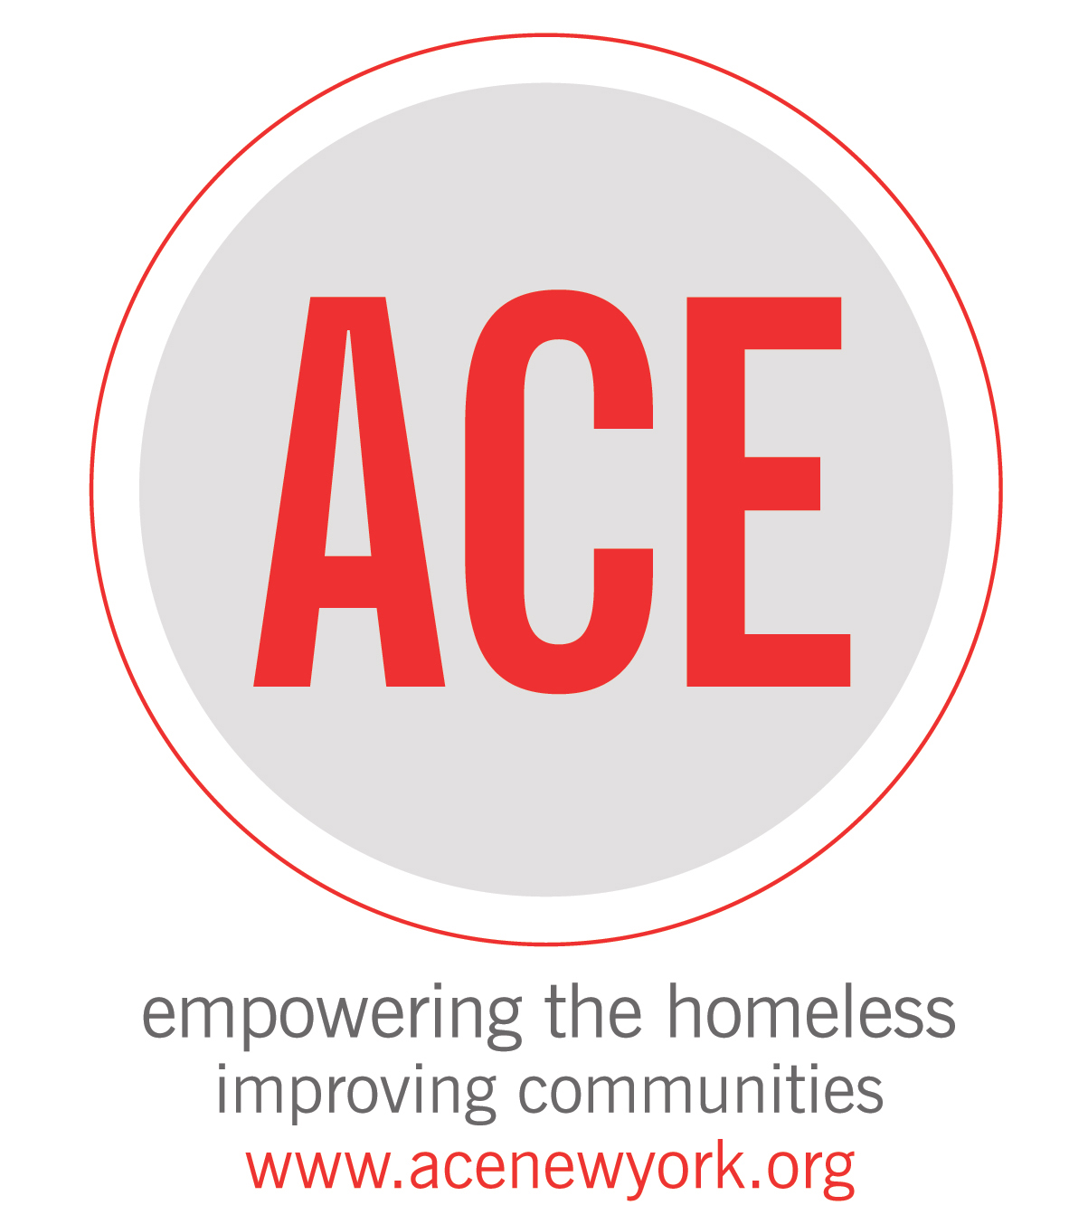

PHOTO/VIDEO RELEASE AND WAIVER

I do hereby give the Association of Community Employment Programs for the Homeless, its assigns, licensees, and legal representatives the irrevocable right to use my testimony, a video of myself, a picture, portrait or photograph in all forms and media and in all manner, for advertising, trade or in any other lawful purpose for the benefit of the Association of Community Employment Programs for the Homeless only. I hereby forever waive any right to inspect or approve the finished product, including but not limited to, written copy and/or an image in print or on a web site, that may be created in connection therewith. I understand that the Association of Community Employment Programs for the Homeless cannot control the unauthorized use by persons other than the Association of Community Employment Programs for the Homeless, of my name or image once such name or image is published. Any claim I may have concerning unauthorized publication of my name and image must be pursued by me against the unauthorized user. The Association of Community Employment Programs for the Homeless disclaims any responsibility for such unauthorized use of my published name or image.

I have had sufficient time to review and seek explanation of the provisions contained above, have carefully read and understand them, and agree to be bound by them. I voluntarily and irrevocably give my consent and agree to this Release and Waiver.

Electronic Signature:

Date:

